

**Software Design Specification**

**Skill Development Project III – ICT 3206**

**Bachelor of Information and Communication Technology (Honors)**

Department of Information and Communication Technology

Faculty of Technology

Rajarata University of Sri Lanka

(*Leave this page blank*)

**Details of the Project**

|  |  |  |  |  |  |  |  |
| --- | --- | --- | --- | --- | --- | --- | --- |
| **Project Title** | : |  | | | | | |
|  |  |  | | | | | |
| **Group Number** | : |  | | | | | |
| **Group Name** | : |  | | | | | |
| **Submission Date** | : |  | | | | | |
| **Details of the Group Members** | | | | | | | |
| **Name** | | | | | **Registration ID** | **Index No.** | **Signature** |
|  | | | | |  |  |  |
|  | | | | |  |  |  |
|  | | | | |  |  |  |
|  | | | | |  |  |  |
|  | | | | |  |  |  |
|  | | | | |  |  |  |
| **Details of Supervisor(s)** | | | | | | | |
| **Name** | | | : |  | | | |
| **Designation** | | | : |  | | | |
| **Department/ Unit/ Institute** | | | : |  | | | |
| **Contact Details** | | | : |  | | | |

**Guideline to fill the document**

1. SDS document should elaborate the details with respect to the Design phase of the project.
2. Your design decisions should tally with the Software Requirements Specification (SRS) which you have already submitted in the previous stage.
3. Software Design Specification document should be prepared using a word processor, clear and coherent.
4. The content of each section in this document should be in detail and make the focal points stand out.
5. A student may have more than one supervisor. In such case, the details of all supervisors should be included on the document.
6. The student can attach additional pages.
7. The student must follow the IEEE format to make the reference list.
8. This document should be printed on both sides of A4 papers (do not print with colors).
9. Each figure/diagram should be numbered along with a caption. All figures/diagrams must be referred within the textual content. The figure number and caption must be placed at the bottom of the figure/diagram.
10. Each table should be numbered along with a caption. All tables must be referred within the textual content. The table number and caption must be placed at the top of the table.

**Submission Guidelines for the document**

1. The student must submit a soft copy of finalized document to the Moodle, as an electronic book version (.pdf) on or before the submission date.
2. Meanwhile, a hard copy of the document which is recommended and approved by the supervisor(s) (with signature(s)), must be submitted to the department before the viva presentation date.
3. The student must submit the second version of the document to the Moodle, after corrections made based on the feedbacks and comments of viva panel as an electronic book version (.pdf). In this case, recommendation and approval page of supervisor(s) and comments/ approval page of viva panel could be scanned and attached at the end of the document in order to make the final document in electronic book version (.pdf).

**Table of Contents**

1 Introduction 1

1.1 Background of the project 1

1.2 Purpose and significance of the project 1

1.3 Scope of the project 1

1.4 Objectives of the Project 1

1.5 System design approach 1

2 Architectural Design 2

2.1 System Architecture 2

2.2 Component design 2

2.3 Processes and interaction design 2

2.4 Tools, libraries, special algorithms and implementation environment 2

3 Interface Design 3

3.1 PACT (People, Activities, Contexts, Technologies) analysis of the system 3

3.2 Interfaces (software/hardware) of the system 3

3.3 Design tools, techniques, templates 3

4 Data Management 4

4.1 Design tools, techniques 4

4.2 Conceptual database design 4

4.3 Logical database design and schema refinement 4

4.4 Physical database design 5

5 Hardware Design (if available) 6

6 Recommendation of supervisor(s) on the document 7

7 Viva presentation assessment team 8

8 Comments of the assessment team on viva presentation 8

**List of Figures**

**List of Tables**

# Introduction

## Background of the project

## Purpose and significance of the project

## Scope of the project

*\* explain the boundaries of your project*

## Objectives of the Project

*\* List the amended and finalized objectives of your project.*

## System design approach

*\* Explain the* ***Software Development Process model(s)*** *(Ex: Agile, SCRUM, etc.) and* ***Design Pattern(s)*** *(Ex: MVC, Client-Server, etc.) with respect to your project.*

# Architectural Design

## System Architecture

*\* Write an overview of the system architecture. Include high-level diagrams such as block diagrams. Explain how the components of the final product works together.*

## Component design

*\* Include the* ***class diagram*** *of the system and give a description of it.*

## Processes and interaction design

*\* Describe the processes of the system using* ***sequence diagrams****.*

## Tools, libraries, special algorithms and implementation environment

# Interface Design

## PACT (People, Activities, Contexts, Technologies) analysis of the system

*\* Describe the four (04) aspect of PACT analysis based on your system.*

## Interfaces (software/hardware) of the system

*\* Describe interfaces (software/hardware) of the system using figures*

## Design tools, techniques, templates

# Data Management

## Design tools, techniques

*\* Describe the tools and techniques use to implement database in the system.*

## Conceptual database design

*\* Describe the ER diagram you draw in the system requirement specification (SRS) stage. Include detailed descriptions of data, relationships and constraints.*

## Logical database design and schema refinement

*\* Describe the enhanced ER (with Cardinalities, Normalization, Primary Keys, Foreign Keys, etc.) using UML format. Include refined-database schema. An example is given below.*

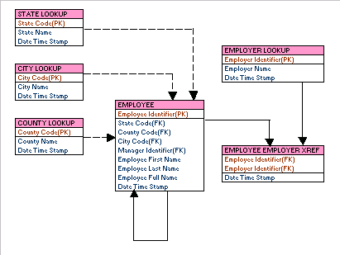

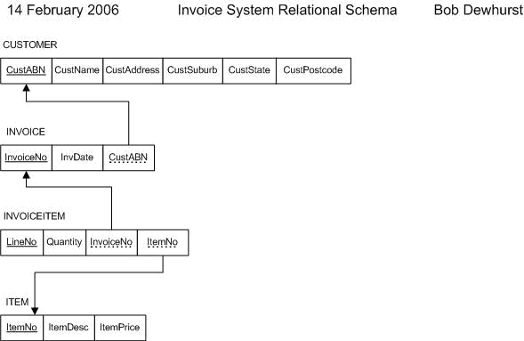

## Physical database design

*\* Describe the enhanced ER (by assigning each attribute with type, length, nullable, etc.) using UML format. Physical ER diagram represents how data should be structured and related in a specific DBMS it is important to consider the convention and restriction of the actual database system in which the database will be created. An example is given below*.

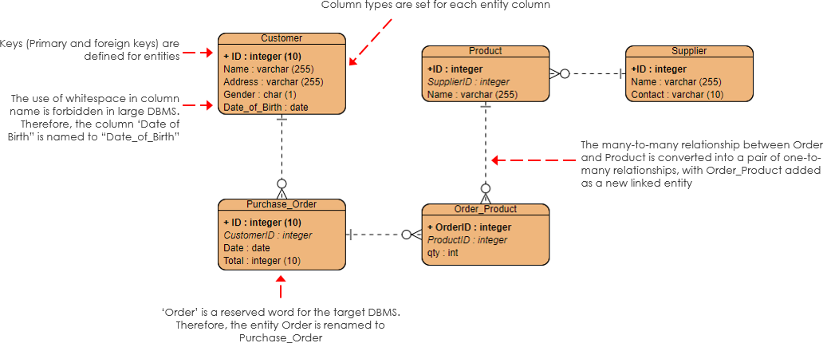

# Hardware Design (if available)

*\* Describe the hardware architecture using block diagrams. Explain how the communications works between the hardware components of the system.*

# Recommendation of supervisor(s) on the document

***(This section should be filled by the supervisor(s)).***

**Comments (if any):**

**I/We certify that, the student engaged continuously with me in developing the proposal and, I am confident that they are adequately competent to defend this viva.**

**Signature(s) of Supervisor(s):**

**Date:**

# Viva presentation assessment team

***(This section should be filled by the department)***

|  |  |  |  |
| --- | --- | --- | --- |
| **Date of viva presentation:** | |  | |
|  | | | |
| **Panel members** | **Name** | | **Department / Institute** |
| **Chair** |  | |  |
| **Member** |  | |  |
| **Member** |  | |  |
| **Member** |  | |  |
| **Member** |  | |  |

# Comments of the assessment team on viva presentation

***(This should be filled by the chair of the assessment panel. In case of revision or fail, needed revision or reasons to fail the viva presentation should be mentioned here)***

|  |  |
| --- | --- |
| **Result of the viva presentation** | **Excellent / Good / Pass with revisions / Fail** |
| **Score** |  |
| **Signature of the panel chair** |  |
| **Date** |  |